Given a binary tree root and a linked list with head as the first node.

Return True if all the elements in the linked list starting from the head correspond to some *downward path* connected in the binary tree otherwise return False.

In this context downward path means a path that starts at some node and goes downwards.

**Example 1:**

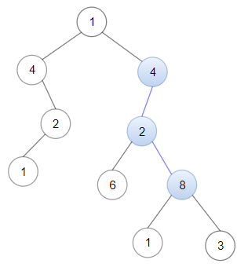

**Input:** head = [4,2,8], root = [1,4,4,null,2,2,null,1,null,6,8,null,null,null,null,1,3]

**Output:** true

**Explanation:** Nodes in blue form a subpath in the binary Tree.

**Example 2:**

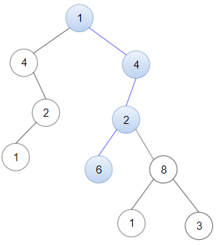

**Input:** head = [1,4,2,6], root = [1,4,4,null,2,2,null,1,null,6,8,null,null,null,null,1,3]

**Output:** true

**Example 3:**

**Input:** head = [1,4,2,6,8], root = [1,4,4,null,2,2,null,1,null,6,8,null,null,null,null,1,3]

**Output:** false

**Explanation:** There is no path in the binary tree that contains all the elements of the linked list from head.

**Constraints:**

* 1 <= node.val <= 100 for each node in the linked list and binary tree.
* The given linked list will contain between 1 and 100 nodes.
* The given binary tree will contain between 1 and 2500 nodes.